Increasing stability in processed meat products

Middle East processed meat trends are evolving, with an emphasis on high quality products and a wider range of products. Ingredient specialist Palsgaard discusses the ways emulsifiers improve the processing parameters and characteristics of these meat products.

By Cai Clemen Christensen, Business Development Manager, Lipid & Fine Food Group Palsgaard A/S.

The Asian and Middle Eastern meat markets are continually growing. According to October 2012 figures from the World Agricultural Outlook Board, many smaller, emerging and price sensitive Asian and Middle Eastern markets fuel rising demand for cost-effective products. Expanding markets for processed meat as well as Halal-certified products provide opportunities for export growth. Manufacturers naturally wish to accommodate these trends alongside reducing the costs of their products in order to become more competitive in the market.

The Board’s 2013 forecast for beef and veal reports the world production has risen slightly for the second consecutive year. Strong expansion by India will balance the reduction in US production. In terms of demand, the Middle East and North African demand is forecast to increase, benefiting key suppliers India and Brazil. Higher imports are forecast, particularly in Saudi Arabia, Algeria and smaller markets such as Oman, Libya and the United Arab Emirates. This will also increase the focus on processed meat in the region and the ways of optimizing the region’s products.

Increase the quality by using emulsifiers
One key process of stabilizing processed meat products and ensure higher quality parameters is by incorporating emulsifiers. Several types can be used in different meat applications and Palsgaard, the Danish emulsifier and stabilizer specialist, has developed a range of ingredients that are particularly suitable for processed meats. Trials have included categories such as sausages and pâtés. Both products are characterized as meat batters and have thermodynamically unstable emulsion systems that need stabilization by emulsifiers, stabilizers or combinations of both.

The emulsifiers already in the batter are the meat proteins (actine and myosine), which are activated by use of phosphates, sodium chloride and shear force. The stabilizers already in the batter are collagen/ gelatin, which together with hydrocolloids stabilize the water phase in the product.

Emulsifiers are surface-active molecules and examples are proteins, phosphor-lipids and mono- and diglycerides of fatty acids and derivatives of these. The below description focuses on the use of the last mentioned group, and the emulsifiers listed in table 1 are used alone or in combinations for creating a stable emulsion and a higher quality of the final meat product.
Deciding the type of emulsifier
In general the meat products can be divided in 2 categories, which also partly decide the type of emulsifiers used for the application - cold processed meat emulsions and warm processed meat emulsions.
The cold processed meat emulsions (0 – 13ºC) include sausage-type products. They are all based on a meat emulsion, which is a suspension of fat particles in a gellified meat and water phase. They are all stuffed in suitable casings. The demands to the emulsifier used are that they have no off-flavours and a good dispersibility in meat batters processed under cold conditions and are effective in creating stable emulsions – especially in products with high fat and water content. They should make it possible to improve quality and/or optimize the cost profile.
To understand the stability issues in the processed meats, it is important to consider the HLB value. The products are multiphase systems that are often unstable, as the components can’t blend to form a solution. There are two aspects to the emulsifiers needed to stabilize them - the lipophilic part often consists of hydrocarbon chains of fatty acids and the hydrophilic part originates from more polar molecules such as glycerol, lactic acid, citric acid and polyglycerol. The types and sizes of these determine the functional behaviour and are shown as the hydrophilic to lipophilic balance (HLB value).

A high HLB value (the hydrophilic moiety dominates the emulsifier) typically stabilizes oil-in-water emulsions, whereas low HLB values will lead to water-in-oil type emulsion. In order to illustrate the functionality of the emulsifiers in cold processed meat emulsions, trials with the citric acid ester of mono- and diglycerides of fatty acids, the high HLB value emulsifier Palsgaard® Citrem 3307 (E472c) were used in sausages. The recipe of the sausages is described below in table 2. To evaluate the functionality of the emulsifier in the produced sausages, the purge loss and the cooking loss were measured as shown below in figure 1.

By using Palsgaard emulsifiers in sausages, it was possible to obtain a very good dispersibility in the meat batters, processed under cold conditions. The trials showed that there was a clear reduction of purge loss in the products during storage in 7, 14 and 28 days when emulsifiers were used in the sausages. Also the cooking loss was reduced in the sausages when Palsgaard® Citrem 3307 was added. These parameters resulted in a high quality of the produced sausages with the possibility to optimize the cost profile and flexibility in raw material selection.
Warm process product trials
Trials were also performed for warm processed emulsified meat products, including pâtés and sausages that are produced with a warm process (50ºC – 80ºC). The products were packed in casings or in cans. In order to illustrate the effect of emulsifiers in these types of meat products, different sausages were produced with and without a distilled mono- glyceride (E471) based on vegetable fats, Palsgaard® DMG 0090 Powder.
The demands to the emulsifiers were that there should be no off flavour or smell to the meat product. They should improve the spreadability and the smoothness of the pâtés and sausages as well as improve the emulsion, so that less fat and water will separate. The recipes used are shown in table 3.
In order to evaluate the effect of the addition of the emulsifier, the stability was measured by centrifugation test and also the storage stability was measured as shown below in figure 4. The trials noted that both the emulsion stability and the storage stability are significantly improved by addition of the emulsifier and an increased dosage will further improve both parameters.
Conclusion
In conclusion, it is possible to improve the qualities of the meat based products. It is of course necessary to perform the tests with your own recipes and also consult the local food legislation if the use of the described emulsifiers is permitted. In addition to the above-mentioned emulsifiers for meat products, Palsgaard also manufactures a wide range of emulsifiers and stabilizer blends for mayonnaise and dressings, margarine, bakery, confectionery, dairy and ice cream.
Table 1:
Emulsifiers used in meat applications
Type of emulsifier E-number
Type of emulsifier | Enumber
Citric acid esters  of mono- and  diglycerides of fatty  acids | E472c
Distilled monoglycerides  and mono- and  diglycerides of fatty  acids | E-471
Combinations of the  above mentioned 2  types of emulsifiers | E-471, E-472c

Table 2:
Recipes of three different sausages with and without Palsgaard® Citrem 3307

Ingredient | Sausage 1 | Sausage 2 | Sausage 3
Meat blend  (40% fat – approx.) | 71.00% | 71.00% | 71.00%
Ice water | 23.30 % | 23.30 % | 23.30%
Palsgaard® Citrem 3307 | 0.00 % | 0.00 % | 0.30 %
Na-caseinate | 0.00 % | 0.30 % | 0.00 %
Soy isolate | 2.00 % | 1.70 % | 1.70 %
Phosphate | 0.25 % | 0.25 % | 0.25 %
Nitrite curing salt | 1.60 % | 1.60 % | 1.60%
Dextrose | 0.30 % | 0.30 % | 0.30 %
Ascorbic acid | 0.05 % | 0.05 % | 0.05 %
Starch | 1.00 % | 1.00 % | 1.00 %
Seasoning | 0.50 % | 0.50 % | 0.50 %
Sum | 100% | 100% | 100%

Table 3:
Recipes of three different liver sausages with and without Palsgaard® DMG 0090

Ingredient | Sausage 1 | Sausage 2 | Sausage 3
Meat blend  (60% fat – approx.) | 64.50% | 64.20% | 64.00%
Liver | 22.40% | 22.40% | 22.40%
Water | 10.00% | 10.00% | 10.00%
Nitrite curing salt | 1.50% | 1.50% | 1.50%
Ascorbic acid | 0.10% | 0.10% | 0.10%
Starch | 1.00% | 1.00% | 1.00%
Palsgaard® DMG 0090 Powder | 0.00% | 0.30% | 0.50%
Seasoning | 0.50% | 0.50% | 0.50%
Sum | 100% | 100% | 100%

Figure 1:
The diagram on the left shows the purge loss % during vacuum storage and the diagram on the right shows the cooking loss %.
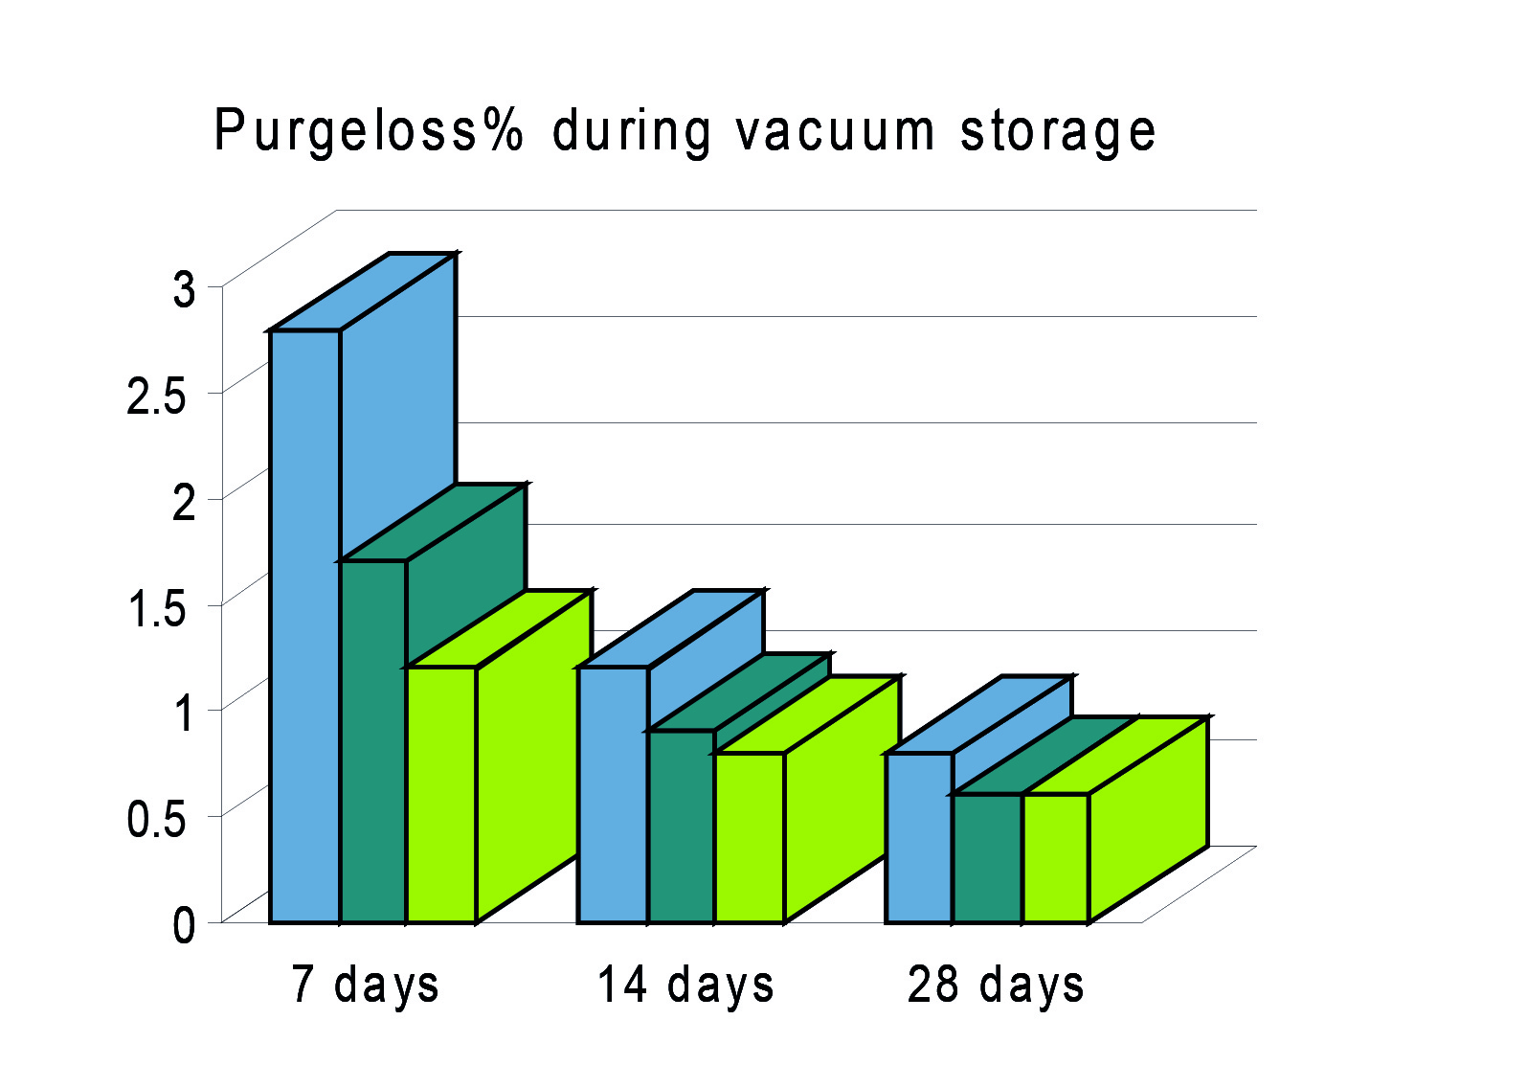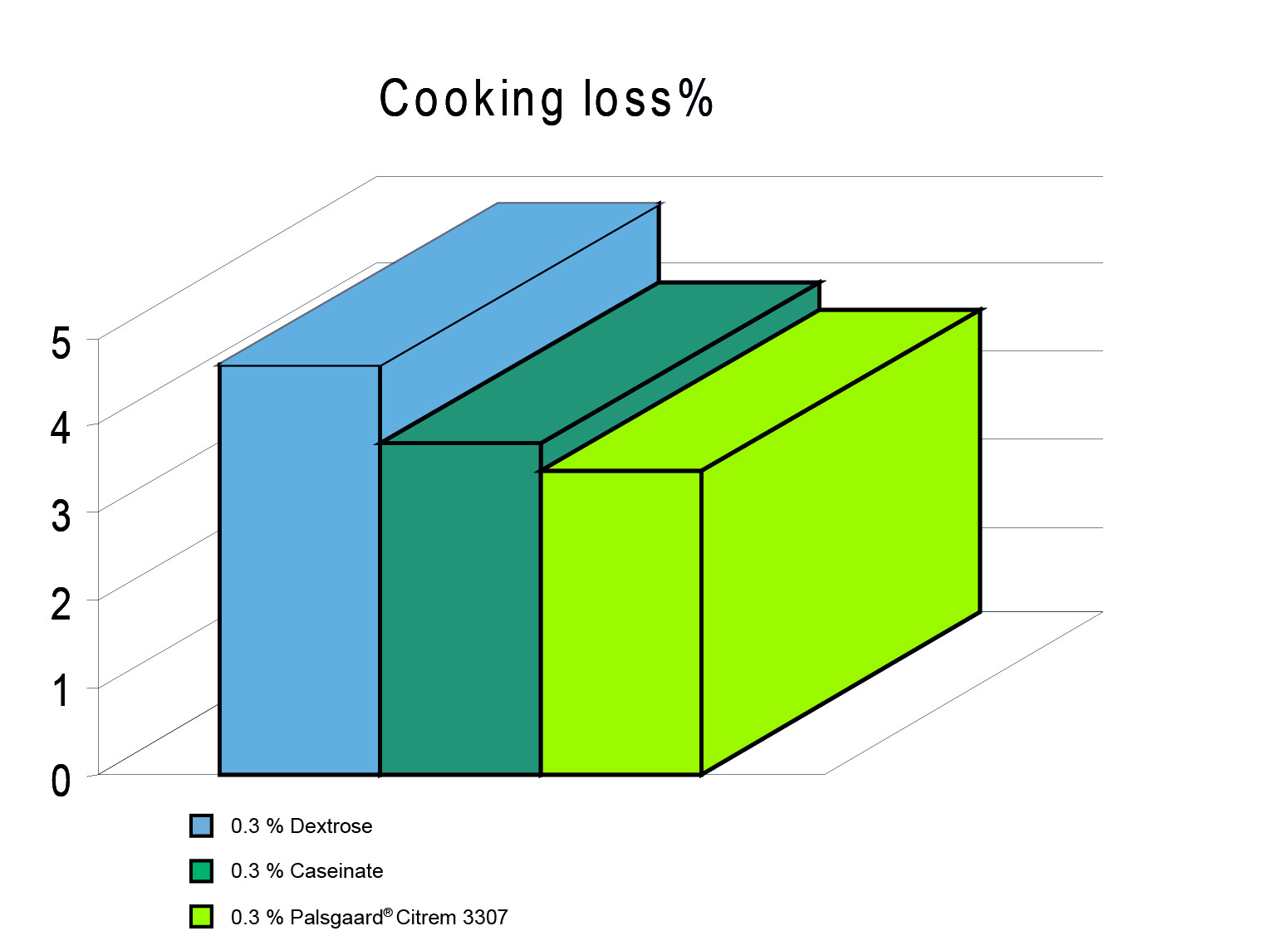

Figure 2
Stability test of liver sausages with and without addition of Palsgaard® DMG 0090. In different dosages.

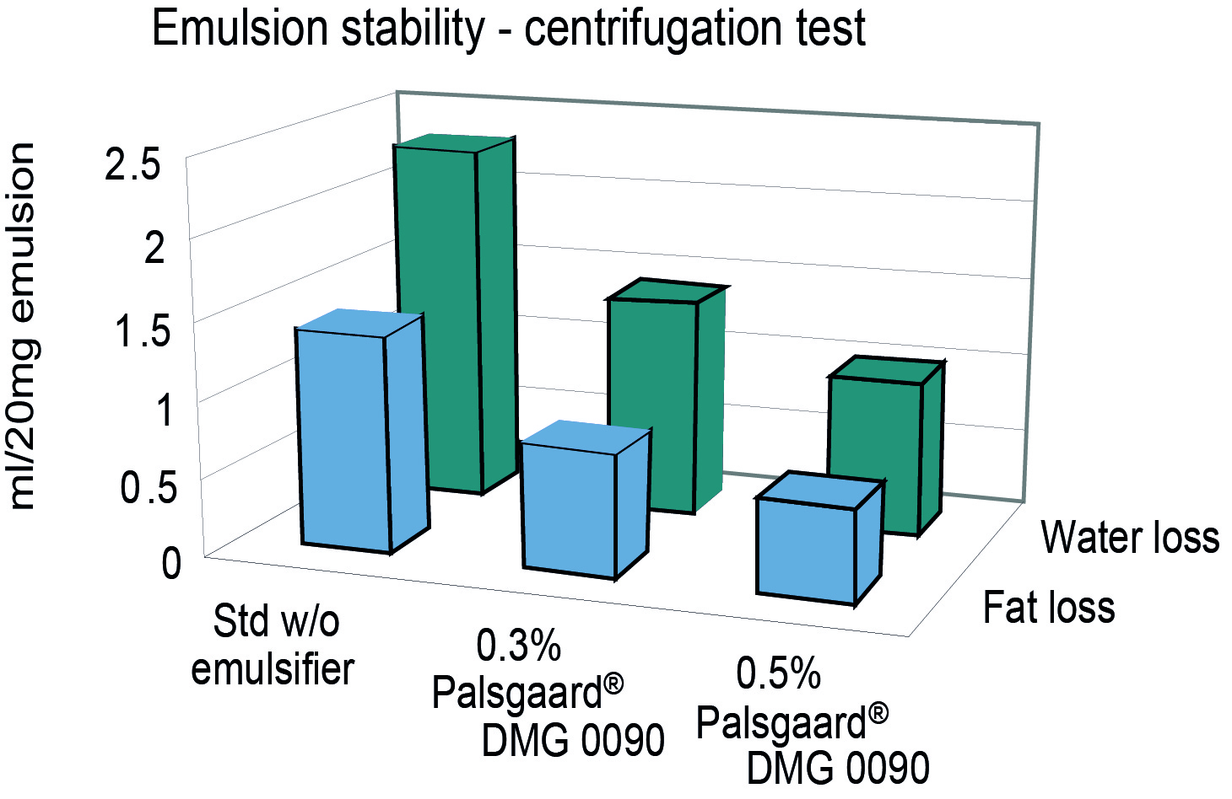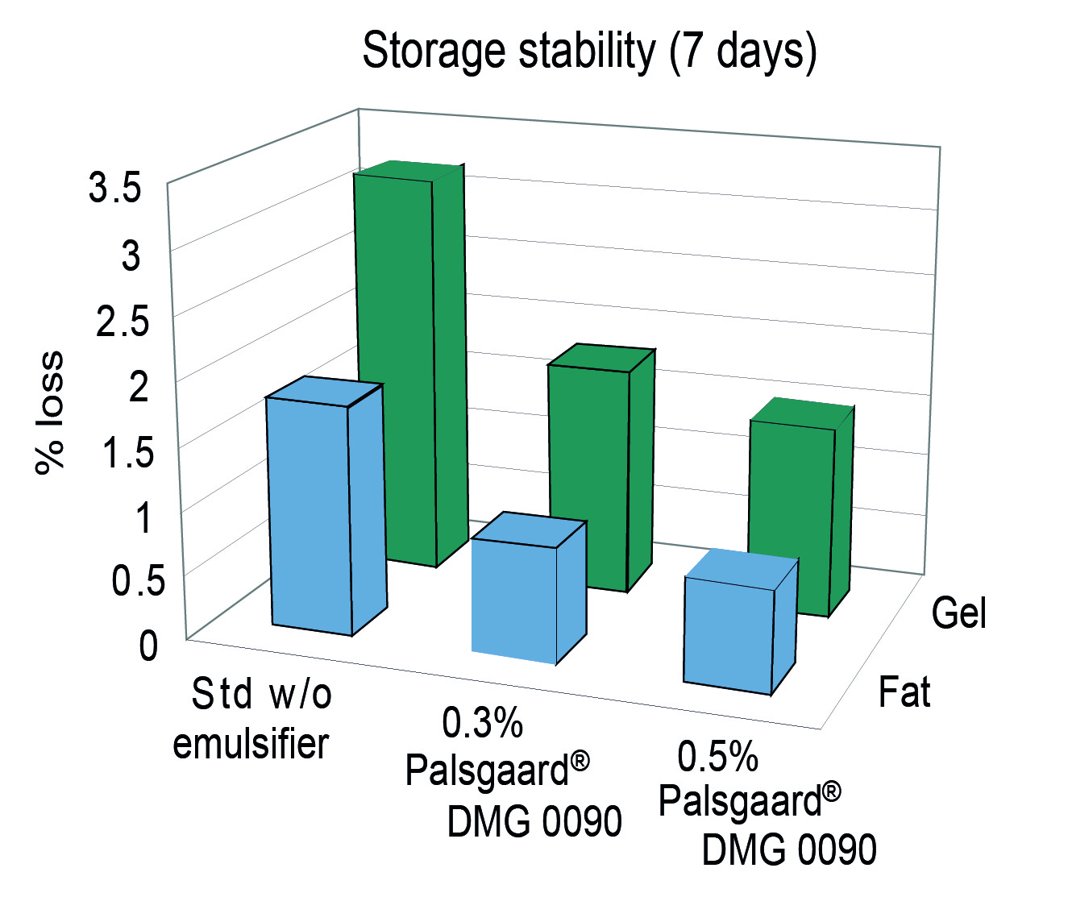

Picture 1
Chicken sausages
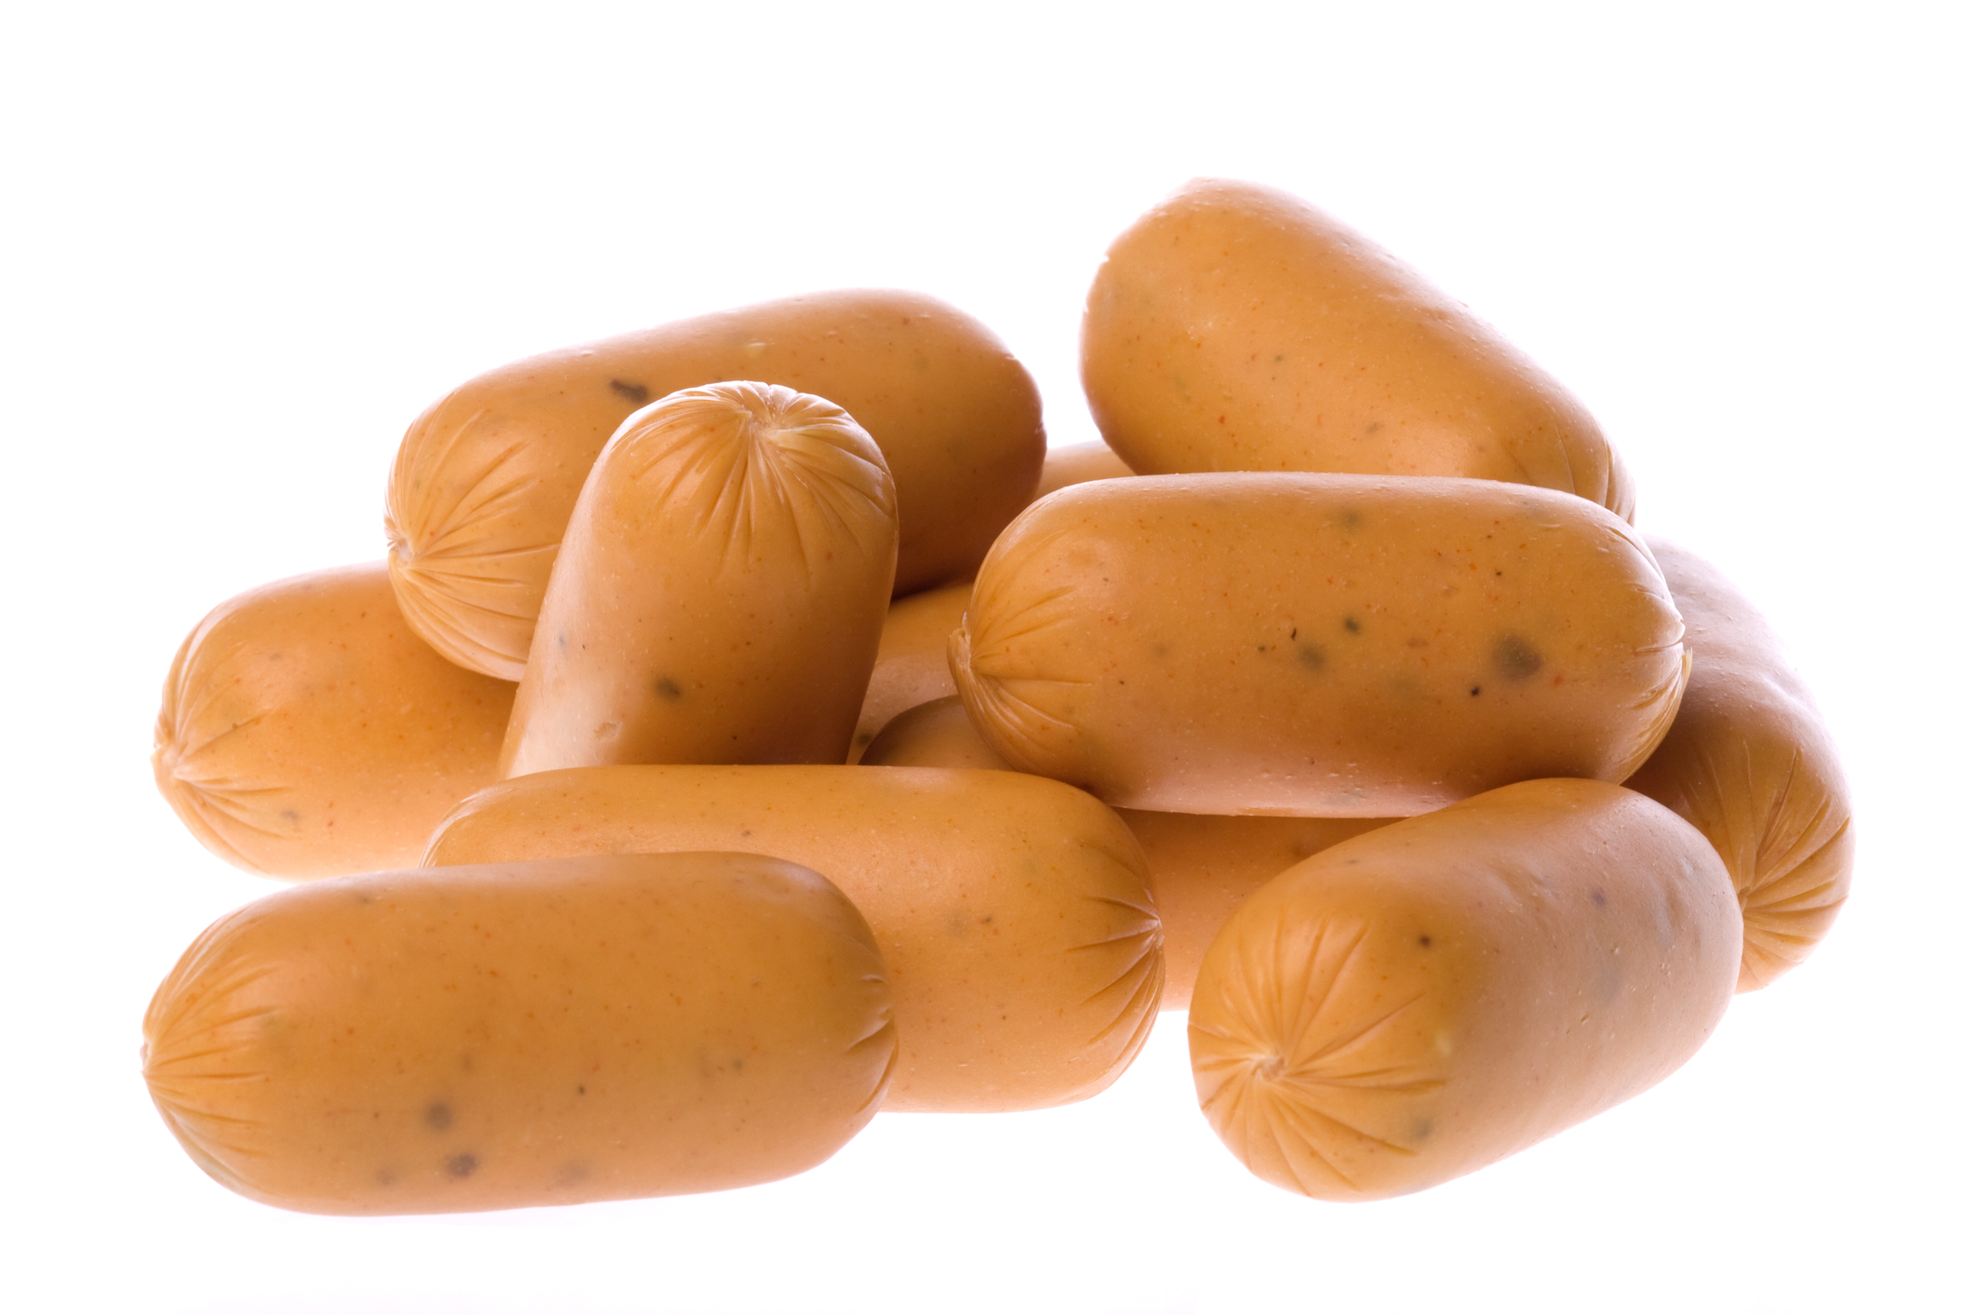

Picture 2
Chicken and veal sausages
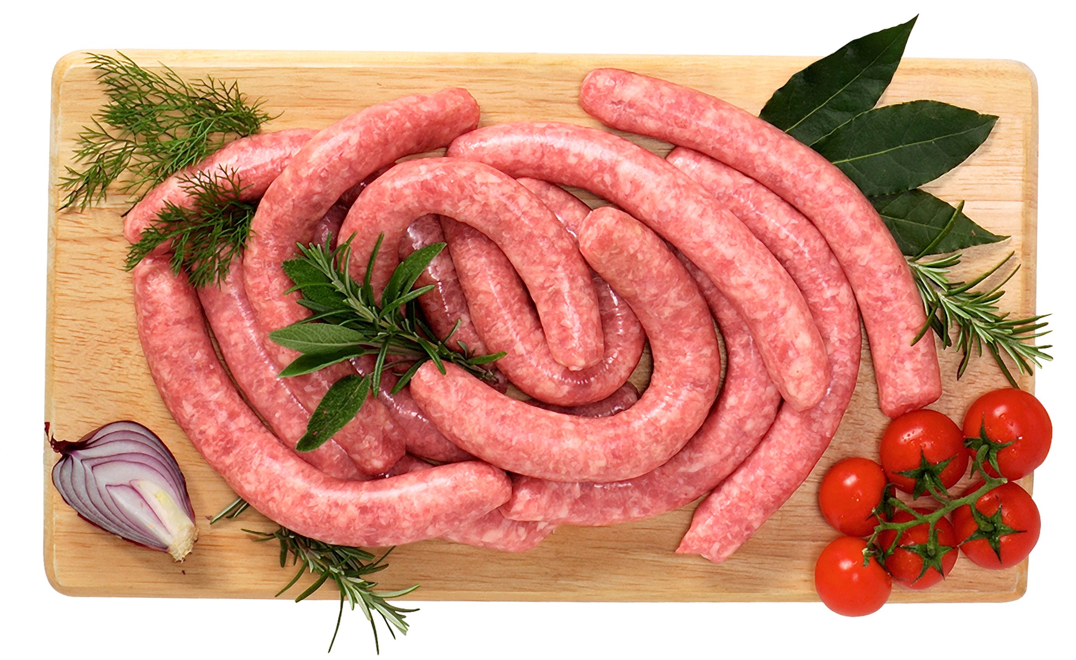

Picture 3
Chicken pâté

